**Analysis Ideas:**

-**What defines success?** What should we use as **metrics of success?**

- Maybe a combined score inclusive of all 4 data sets

- **Sensitivity analysis** (with weights like we did in class)

- Account for Different Years, Trends

-**Cross analyze interactions** between elementary/middle school vs highschool

**What does it mean for a student to be successful? (Liv)**

* Graduation rate

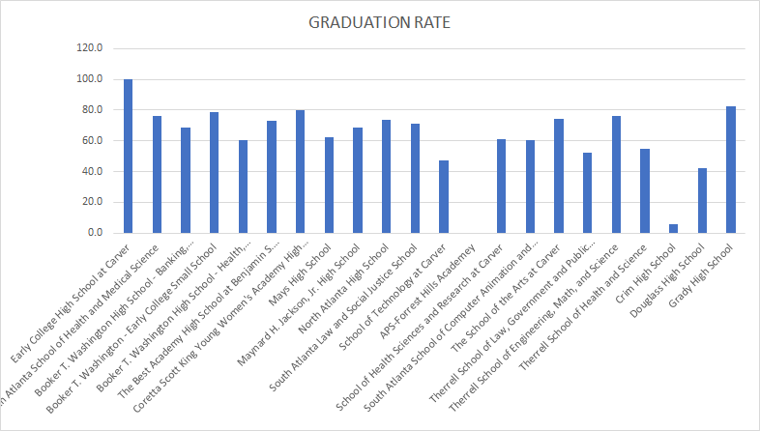

* Gifted and talented students
  + What types of students are in this program?
  + Does the makeup of this program change over grades?
* Success rates in individual subjects/classes
  + Elementary school data on test scores
  + HS data on class pass/fail
  + Compare trends between elementary, middle and high

**Data years/Timelines:**

* Atlanta elementary and middle school data (2013 and 2014 data comparisons of 3-8th grade)
* District graduation rates (Atlanta -2014, NYC-2001-2010, Peer Districts -unknown)
* HS student level data (2007-2012, 4-year student high school history)
* Student-level data(2011)

**Questions posed in case document:**

* How do student outcomes in APS compare to other districts?
  + Data set: **District Graduation Rates**
  + Compare graduation rates with peer districts, account for graduation rates (ATL) only being for 2014 - use NYC data to draw conclusions about trends for this year
  + Tests:
    - T-test comparing average ATL grad rate with TUDA grad rates and non-TUDA grad rates
    - ANOVA on counties
      * Look at different types of scores for each grade
* How are individual schools within APS performing and where should APS focus its efforts to improve student achievement?
  + Look at scores across schools and across grades
  + Student-level data 2011 (sch.number) matches to District Graduation Rates (SCHOOLID)
  + ANOVA value add for elementary middle high
  + Does APS have programs, mainly in their Elementary and Middle schools that have helped some schools outperform?
    - Seems like we’ll have to consider an experimental design perspective, e.g. threats to internal and external validity
    - Value-added (behind, on-track, excelling)
      * Use Atlanta Elementary and Middle School dataset

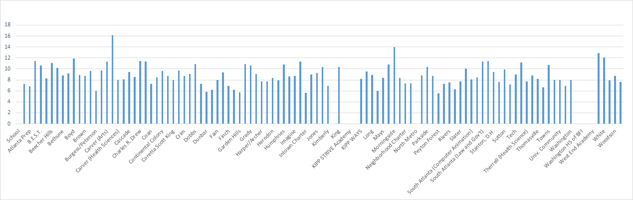

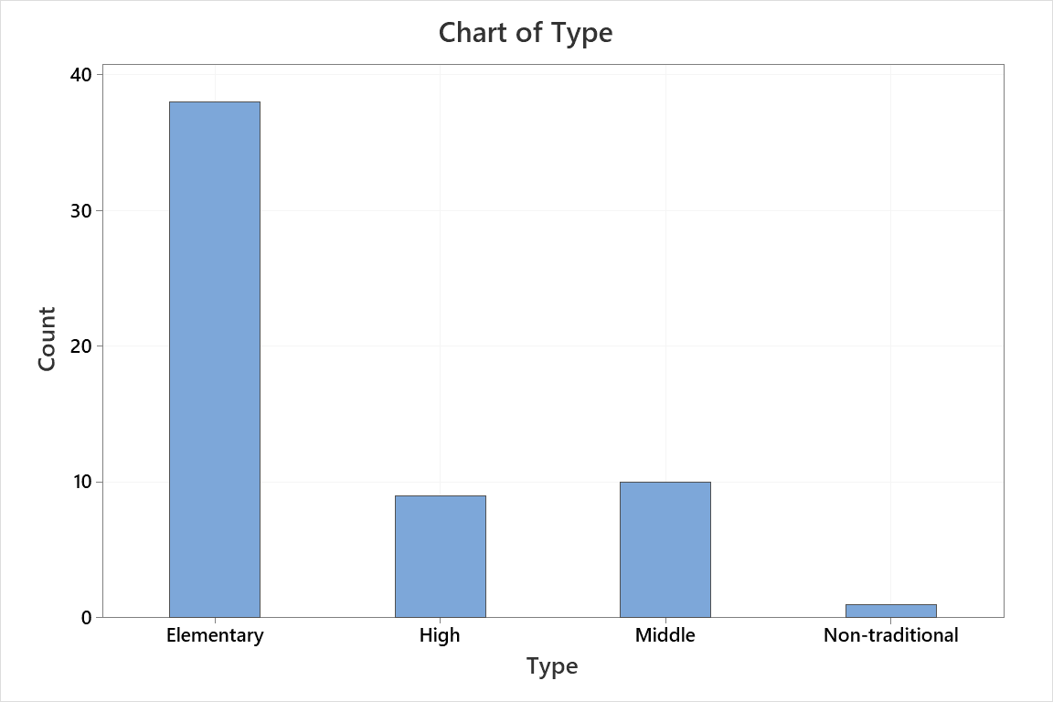

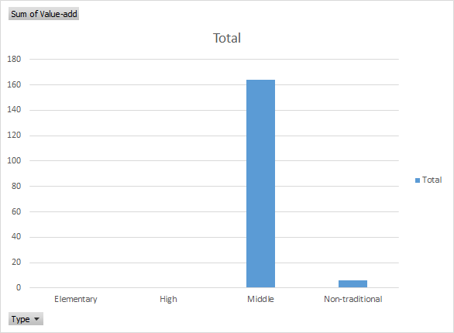

* + Should APS continue to foster a culture of allowing schools to experiment and implement their own, preferred practices? Or should APS try to centralize and standardize more programs?
    - How can we define/understand participation in these programs?
    - What is the spread of performance between schools in APS?
* Dataset: Student-level data 2011, measuring performance of these students

|  |
| --- |
| **activeEnrollment.migrant** |

|  |  |  |  |  |
| --- | --- | --- | --- | --- |
| **es.giftedEligibility** | **activeEnrollment.giftedTalented** | **activeEnrollment.eip** | **activeEnrollment.specialEdStatus** | **activeEnrollment.disability1** |

* How is attendance and student mobility (movement of students within the district) factoring into school performance?
  + Running statistical tests to determine if there is a correlation between elementary school students, highschool students, and attendance rate. Using metrics from Student-level Data 2011
* Are students entering high school ready to succeed? Are there subjects or specific schools where students appear to be underprepared to succeed when they enter high school?
  + Break down failure rates by grade and by subject
  + Compare subject scores (reading, ELA, math, science, social studies) for grades 3-8 to failed courses in high school (english, math, science, social studies)
  + Comparing % not met in grades 5 and 8 (leaving elementary school and leaving highschool)
  + Comparing % not met in grades 6,7,8 (progression through middle school)
* Is there anything APS can do in the short-term to create a “quick win” that can motivate a commitment to longer-term change? (note: The AJC, the local newspaper, has been particularly critical of APS’ low graduation rate)
  + Better preparation for one specific class in one specific grade
  + Reward for graduating other than diploma
  + Investigate most common complaints in the news, address the most public issue
  + A way to increase the graduation rates?
* What other information or analysis should APS pursue to create the fact base necessary to develop a strategy for improving student achievement?
  + National Averages (graduation rate, demographics of students shown in Student-Level Data)
  + Employment Data for the area at the overall population level
    - How are families and parents affecting their childrens’ education
  + Healthcare Data for the area at the overall population level
    - Do students have equal access to healthcare
  + Food Security in the area at the overall population level
    - Are children hungry and distracted causing them to do poorly in school?
  + Diversity of the area at the overall population level
    - Do minorities struggle in the area? How diverse is the area?
  + Crime data for each area
    - Are the students safe?

**TUESDAY: BAIN**

-Findings:

1. We are seeing a correlation between test scores and graduation rates, we want to further test these data points to determine if this might be a false correlation.
   1. Metrics?
      1. % of students who met standards? Score itself?
      2. Cohort grad rate vs other metrics for graduation?
2. We noticed a correlation between the number of eligible gifted students in school levels and higher test scores at those levels.
3. We want to further analyze hindrance of success (graduation rates) which we believe could be caused by mobility, ethnicity, homeless, etc. metrics.

**Bain Notes/Questions**

* Graduation rates
  + Relationship between test scores and graduation rates?
* Pass/fail
  + Relationship between pass fail and test scores?
  + Are test scores a good predictor of success?
* Gifted students and success?
* Further attendance analysis?

How do you deal with scope in a situation like this? Like socioeconomic status and stuff. -

Difference between male and female students? Grad rates?

Current State analysis (where do we stand now? Where do we want to be in the future?)

**Notes from other presentations:**

-We might not want to compare APS to all medians in Georgia, watch comparisons (and maybe narrow them down) we might want to only compare some schools within APS to specific others

- quartiles and binning can be a good was to compare groups which may be hard to comprehend otherwise

-Both widespread and individual school levels analysis (and recommendations) can be helpful, look at schools behind but also schools that are doing well. Actionables are the most helpful - immediate actions.

-Value--add might out trump something like test scores??

- What are the immediate changes we can make?

- Urban vs suburban school comparison

**Follow up notes:**

* 9th grade dropout
  + Low 8th grade test scores
  + Are generally low in middle school? Or just 8th?
    - 8th grade doesn’t really stand out
    - Where is the root cause?
  + Lowest attendance in 9th grade
* race/ethnicity/gender
  + Investigate using data we have
  + Looking into external context
  + Test scores
  + Other metrics
* Merge student level data on school number to find graduation rate data
* Merge student level data on school number to get value add rates
* Link high school groupings with elementary and middle schools
* Homelessness, disability, school lunch
  + Investigate using data we have
  + Looking into external context
  + Test scores
  + Other metrics

**What’s the Problem?**

* Get students to show up in the first place
  + Focus on attendance
* Most students dropout of school in 9th grade, we need programs to prevent this
  + Look for indications of dropout